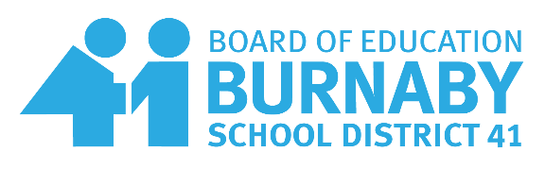
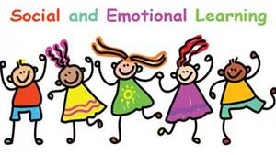

本拿比教育局移民安頓輔導舉辦

家長們可一起學習和探討：
- 了解卑詩省學校系統
- 中西文化不同的挑戰
- 家長如何幫助孩子學業成功
- 培養學生社交,知識,藝術,體能及社會責任感的全面發展
- 家長和青少年之間的衝突
- 如何控制自己的情緒

Parents can come together to learn and discuss together about:

- Understanding BC School system
- Eastern Vs Western (Cultural Difference)
- Parent - How to Help Your Child Succeed at School
- Help Children develop other interests
- Conflicts between Parents and Teens

- As parents how to control their emotions

地點(Place): Chaffey-Burke Elementary School, 4404 Sardis Street Burnaby,
日期(Date): 10/21, 10/28 ,11/04 , 11/18, 11/25星期三
時間(Time): 1:30-3:00pm
語言(Language): 國語 (Mandarin)
咨詢和報名 (Enquiries & Registration): caren.yu@sd41.bc.ca
Caren Yu 604-760-3861 - cell

報名請提供楓葉卡信息
